Homework#2(학번: 2024254002, 서명: 전창수)

1. Feature Detection  
Stitching.zip에서 4장의 영상(boat1, budapest1, newspaper1, s1)을 선택한 후에 Canny Edge와 Harris Corner를 검출해서 결과를 출력하는 코드를 작성하시오.

import cv2  
import numpy as np  
import matplotlib.pyplot as plt  
  
# List of image file paths  
image_paths = ['images/boat1.jpg', 'images/budapest1.jpg', 'images/newspaper1.jpg', 'images/s1.jpg']  
  
# Function to detect Harris Corners  
def detect_harris_corners(image, block_size=2, ksize=3, k=0.04):  
 gray = cv2.cvtColor(image, cv2.COLOR_BGR2GRAY)  
 gray = np.float32(gray)  
 harris_corners = cv2.cornerHarris(gray, block_size, ksize, k)  
 # Result is dilated for marking the corners  
 harris_corners = cv2.dilate(harris_corners, None)  
 # Threshold for an optimal value, it may vary depending on the image  
 image[harris_corners > 0.01 * harris_corners.max()] = [0, 0, 255]  
 return image  
  
# Process each image  
for image_path in image_paths:  
 # Read the image  
 image = cv2.imread(image_path)  
  
 # Canny Edge Detection  
 gray_image = cv2.cvtColor(image, cv2.COLOR_BGR2GRAY)  
 edges = cv2.Canny(gray_image, 100, 200)  
  
 # Harris Corner Detection  
 harris_image = image.copy()  
 harris_image = detect_harris_corners(harris_image)  
  
 # Display the results  
 plt.figure(figsize=(15, 10))  
  
 # Original Image  
 plt.subplot(1, 3, 1)  
 plt.title(f'Original - {image_path}')  
 plt.imshow(cv2.cvtColor(image, cv2.COLOR_BGR2RGB))  
 plt.axis('off')  
  
 # Canny Edge Detection Result  
 plt.subplot(1, 3, 2)  
 plt.title(f'Canny Edge Detection - {image_path}')  
 plt.imshow(edges, cmap='gray')  
 plt.axis('off')  
  
 # Harris Corner Detection Result  
 plt.subplot(1, 3, 3)  
 plt.title(f'Harris Corner Detection - {image_path}')  
 plt.imshow(cv2.cvtColor(harris_image, cv2.COLOR_BGR2RGB))  
 plt.axis('off')  
  
 plt.show()

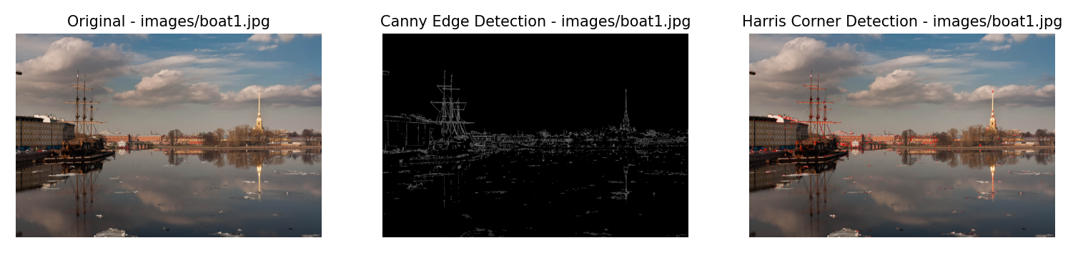

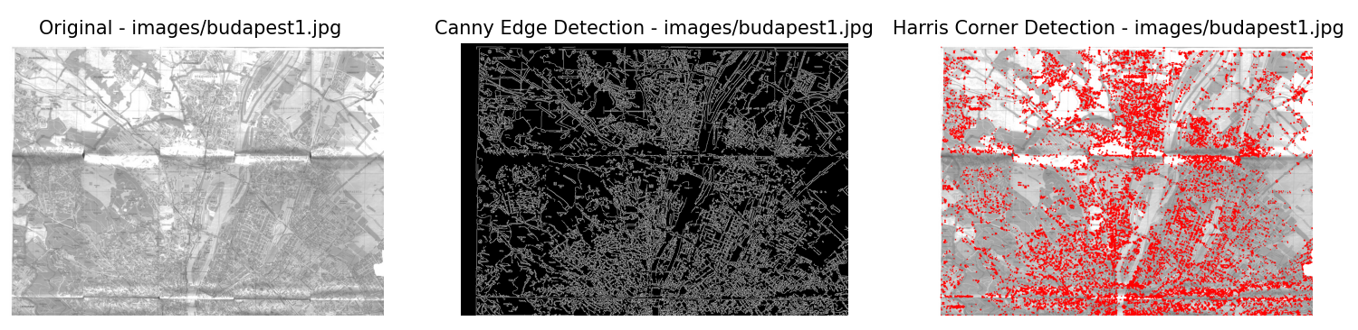

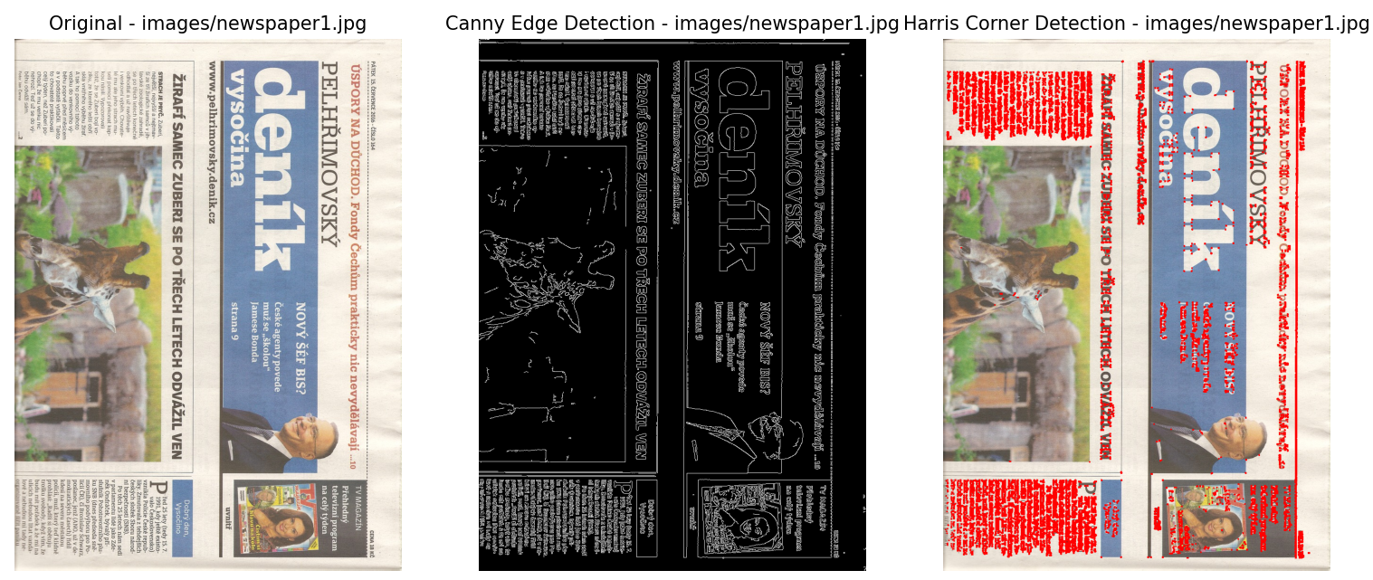

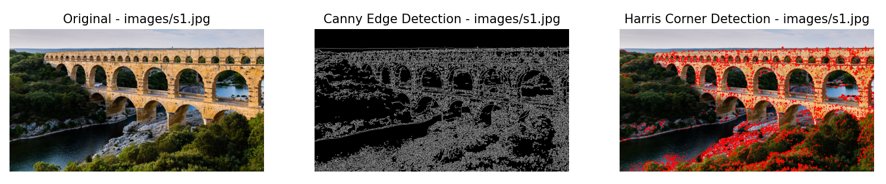

2. Matching  
Stitching.zip에서 각 영상셋(boat, budapest, newspaper, s1~s2)에서 두장을 선택하고 각 영상에서 각각 SIFT, SURF, ORB를 추출한 후에 매칭 및 RANSAC을 통해서 두 장의 영상 간의 homography를 계산하고, 이를 통해 한 장의 영상을 다른 한 장의 영상으로 warping하는 코드를 작성하시오.

import cv2  
import numpy as np  
import matplotlib.pyplot as plt  
  
# Define the image sets  
image_sets = [  
 ('images/boat1.jpg', 'images/boat2.jpg'),  
 ('images/budapest1.jpg', 'images/budapest2.jpg'),  
 ('images/newspaper1.jpg', 'images/newspaper2.jpg'),  
 ('images/s1.jpg', 'images/s2.jpg')  
]  
  
  
# Function to detect keypoints and descriptors  
def detect_and_compute(image, method='SIFT'):  
 if method == 'SIFT':  
 detector = cv2.SIFT_create()  
 elif method == 'ORB':  
 detector = cv2.ORB_create()  
 else:  
 raise ValueError("Method should be 'SIFT' or 'ORB'")  
  
 keypoints, descriptors = detector.detectAndCompute(image, None)  
 return keypoints, descriptors  
  
  
# Function to match descriptors and find homography  
def match_and_find_homography(kp1, des1, kp2, des2, method):  
 if method == 'SIFT':  
 matcher = cv2.BFMatcher(cv2.NORM_L2, crossCheck=False)  
 elif method == 'ORB':  
 matcher = cv2.BFMatcher(cv2.NORM_HAMMING, crossCheck=False)  
 else:  
 raise ValueError("Method should be 'SIFT' or 'ORB'")  
  
 matches = matcher.knnMatch(des1, des2, k=2)  
  
 # Apply ratio test  
 good_matches = []  
 for m, n in matches:  
 if m.distance < 0.75 * n.distance:  
 good_matches.append(m)  
  
 if len(good_matches) > 4:  
 src_pts = np.float32([kp1[m.queryIdx].pt for m in good_matches]).reshape(-1, 1, 2)  
 dst_pts = np.float32([kp2[m.trainIdx].pt for m in good_matches]).reshape(-1, 1, 2)  
  
 H, mask = cv2.findHomography(src_pts, dst_pts, cv2.RANSAC, 5.0)  
 matches_mask = mask.ravel().tolist()  
 else:  
 H = None  
 matches_mask = None  
  
 return H, matches_mask, good_matches  
  
  
# Function to display matches using matplotlib  
def display_matches(img1, kp1, img2, kp2, matches, matches_mask, method):  
 if matches_mask is not None:  
 matches_mask = [[m] * 2 for m in matches_mask] # Convert matches_mask to the correct format  
  
 img_matches = cv2.drawMatchesKnn(img1, kp1, img2, kp2, [[m] for m in matches], None,  
 matchesMask=matches_mask, flags=cv2.DrawMatchesFlags_NOT_DRAW_SINGLE_POINTS)  
 img_matches = cv2.resize(img_matches, (0, 0), fx=0.5, fy=0.5)  
  
 plt.figure(figsize=(20, 10))  
 plt.title(f'{method} Matches')  
 plt.imshow(cv2.cvtColor(img_matches, cv2.COLOR_BGR2RGB))  
 plt.axis('off')  
 plt.show()  
  
  
# Function to warp image  
def warp_image(img1, img2, H):  
 height, width, channels = img2.shape  
 img1_warped = cv2.warpPerspective(img1, H, (width, height))  
 return img1_warped  
  
  
# Function to pad image to match size  
def pad_image_to_match(img, target_shape):  
 height, width = target_shape[:2]  
 img_padded = np.zeros((height, width, 3), dtype=np.uint8)  
 img_padded[:img.shape[0], :img.shape[1], :] = img  
 return img_padded  
  
  
# Process each image set with SIFT and ORB  
for img1_path, img2_path in image_sets:  
 img1 = cv2.imread(img1_path, cv2.IMREAD_COLOR)  
 img2 = cv2.imread(img2_path, cv2.IMREAD_COLOR)  
  
 for method in ['SIFT', 'ORB']:  
 print(f"Processing {img1_path} and {img2_path} with {method}")  
  
 kp1, des1 = detect_and_compute(img1, method)  
 kp2, des2 = detect_and_compute(img2, method)  
  
 if kp1 is None or kp2 is None or des1 is None or des2 is None:  
 print(f"Skipping {method} due to missing keypoints/descriptors.")  
 continue  
  
 H, matches_mask, good_matches = match_and_find_homography(kp1, des1, kp2, des2, method)  
  
 if H is not None:  
 display_matches(img1, kp1, img2, kp2, good_matches, matches_mask, method)  
  
 # Warp image  
 img1_warped = warp_image(img1, img2, H)  
  
 # Pad images to the same size  
 img1_warped_padded = pad_image_to_match(img1_warped, img2.shape)  
 combined = np.hstack((img2, img1_warped_padded))  
 combined = cv2.resize(combined, (0, 0), fx=0.5, fy=0.5)  
  
 plt.figure(figsize=(20, 10))  
 plt.title(f'{method} Warped Image')  
 plt.imshow(cv2.cvtColor(combined, cv2.COLOR_BGR2RGB))  
 plt.axis('off')  
 plt.show()  
 else:  
 print(f"Not enough matches found for {method} to compute homography.")

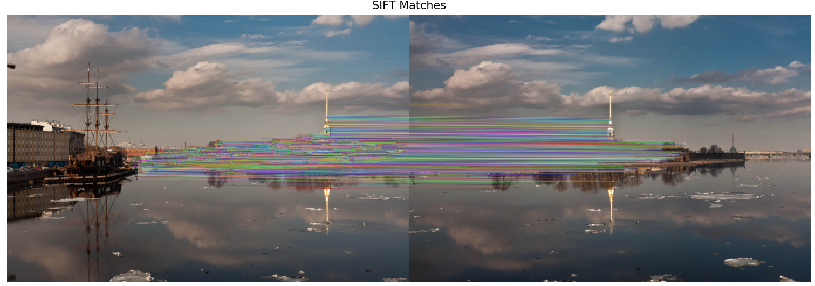

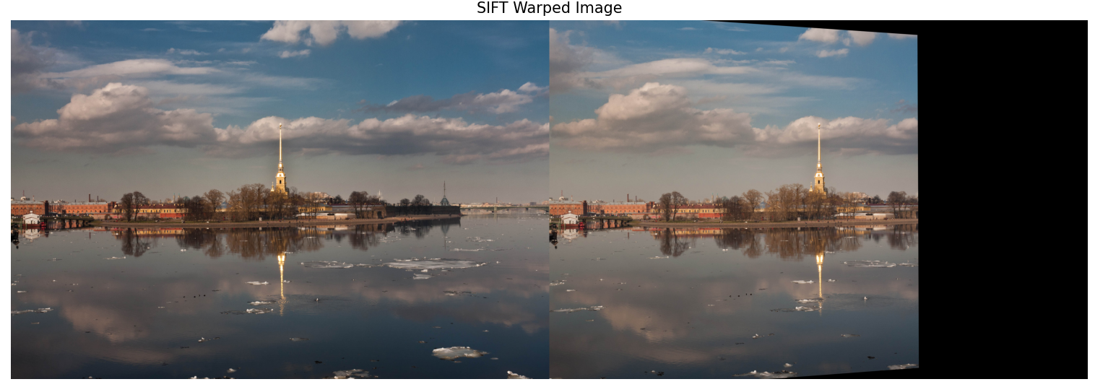

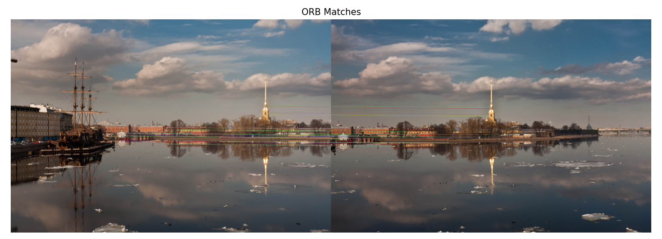

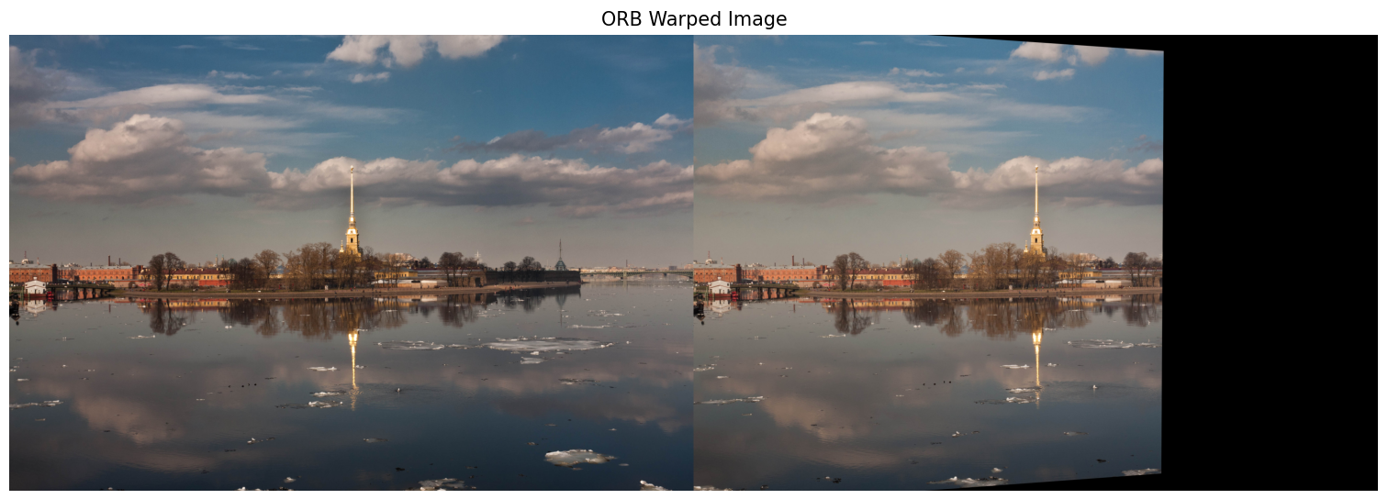

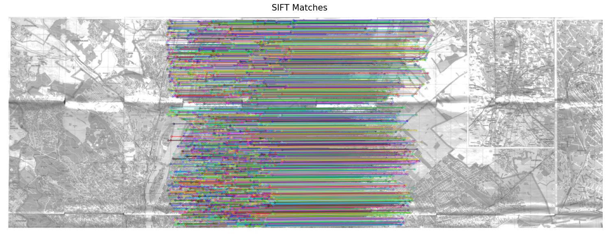

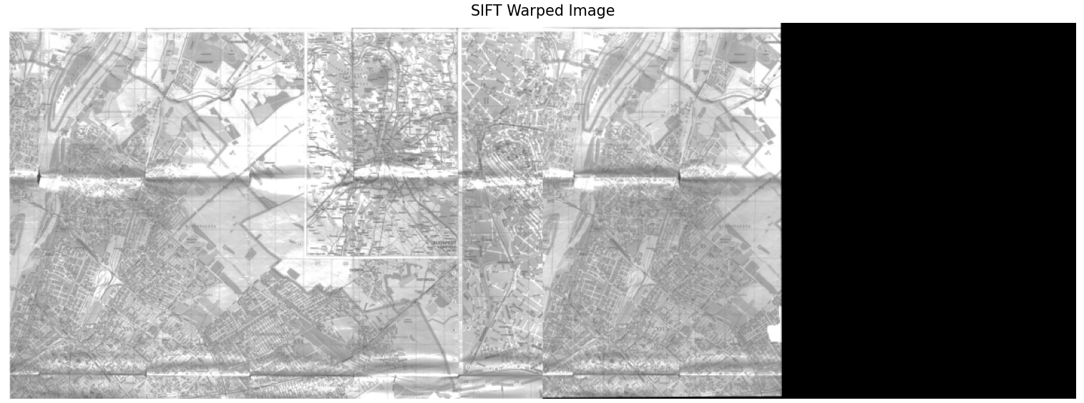

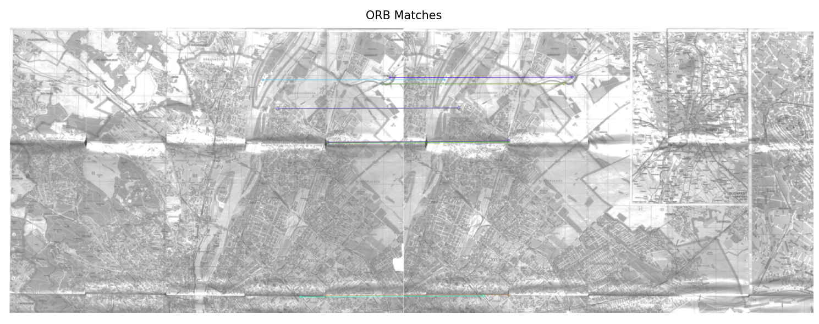

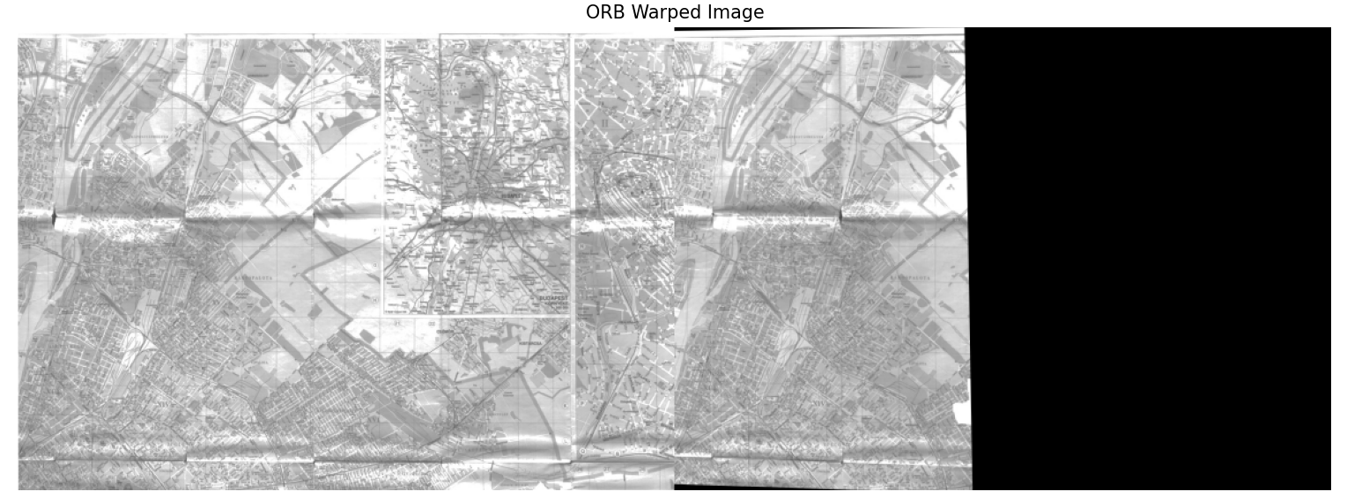

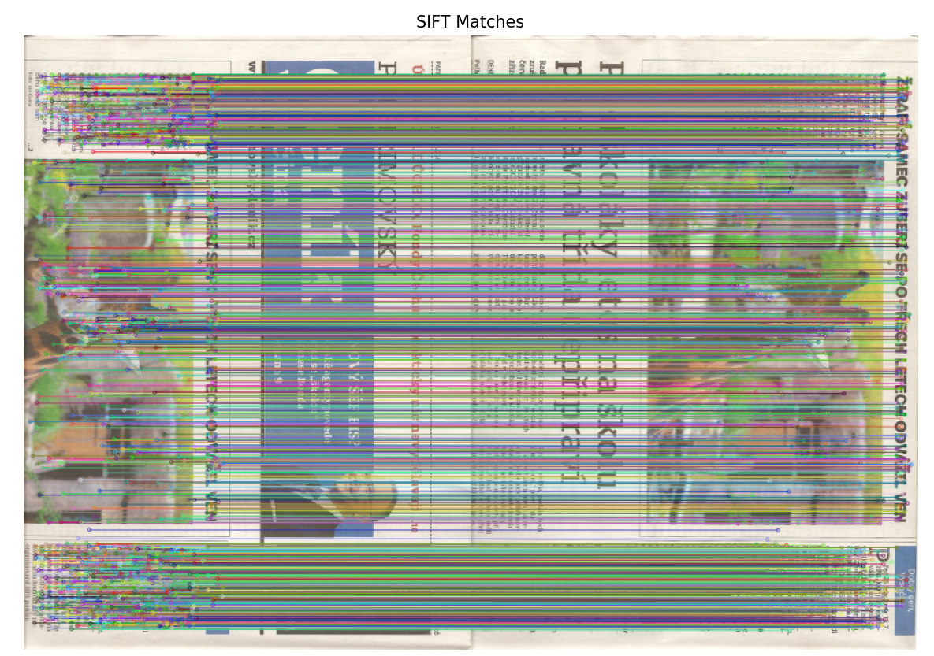

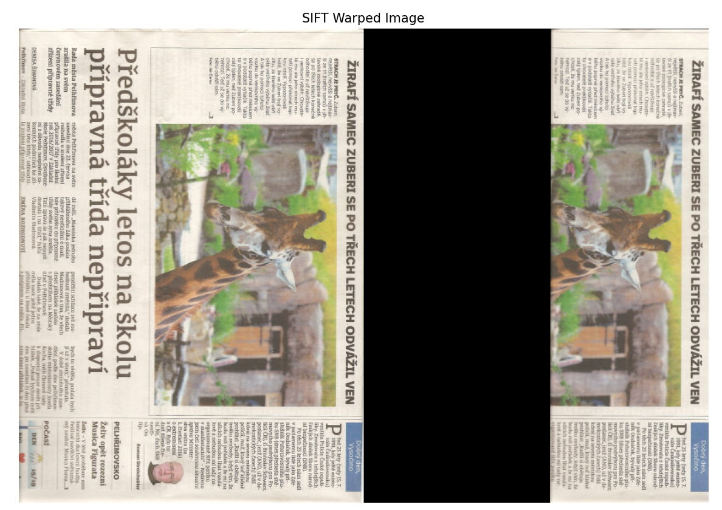

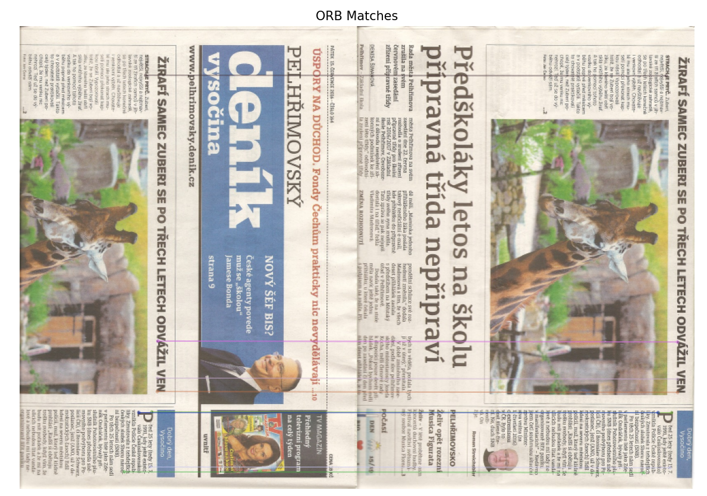

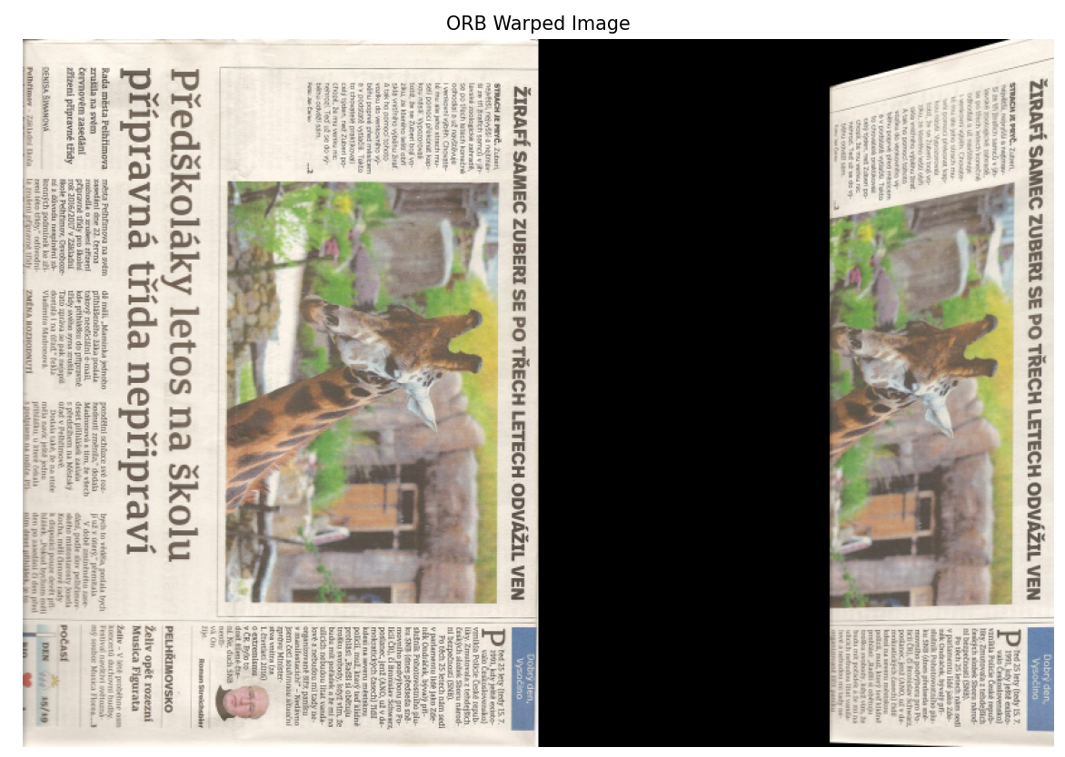

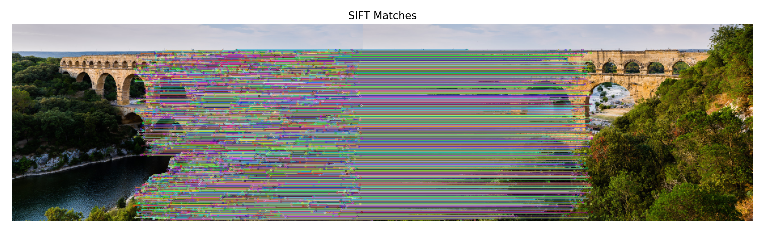

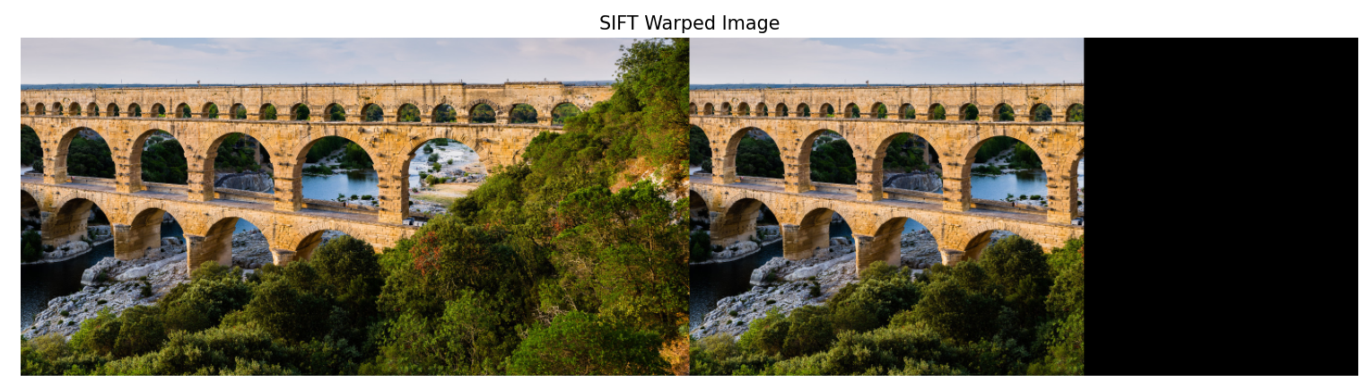

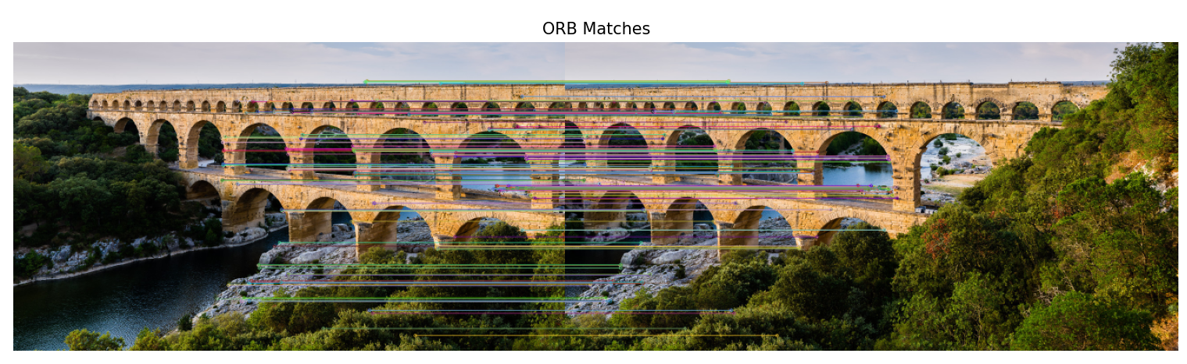

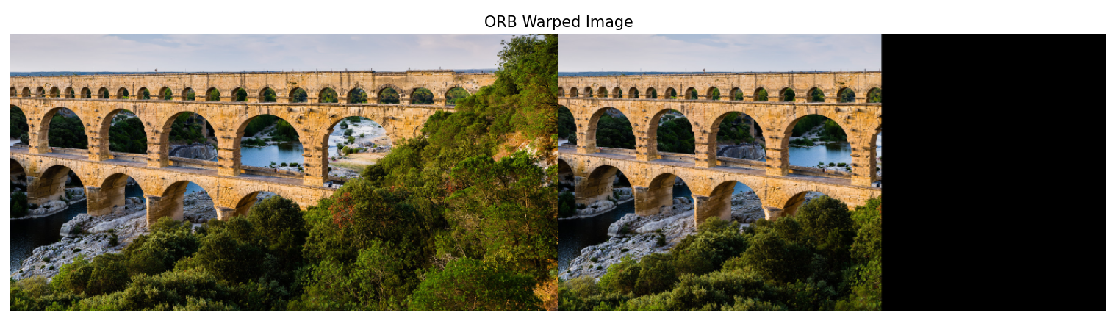

3. Panorama  
CreaterStitcher 함수를 이용하여 4개의 영상 셋에 대해서 파노라마 이미지를 만드는 방법을 구현하시오.

import cv2  
from matplotlib import pyplot as plt  
  
  
def display_image(title, image):  
 plt.figure(figsize=(20, 10))  
 plt.title(title)  
 plt.imshow(cv2.cvtColor(image, cv2.COLOR_BGR2RGB))  
 plt.axis('off')  
 plt.show()  
  
  
def create_panorama(image_paths):  
 # Load the images  
 images = [cv2.imread(image_path) for image_path in image_paths]  
  
 # Check if all images are loaded correctly  
 if any(image is None for image in images):  
 print("Error: One or more images could not be loaded. Check the file paths.")  
 return None  
  
 # Create a Stitcher instance  
 stitcher = cv2.Stitcher_create()  
  
 # Stitch the images  
 status, panorama = stitcher.stitch(images)  
  
 if status == cv2.Stitcher_OK:  
 return panorama  
 else:  
 print("Error during stitching:", status)  
 return None  
  
  
# Image paths for each set  
image_sets = {  
 'boat': ['images/boat1.jpg', 'images/boat2.jpg', 'images/boat3.jpg', 'images/boat4.jpg', 'images/boat5.jpg',  
 'images/boat6.jpg'],  
 'budapest': ['images/budapest1.jpg', 'images/budapest2.jpg', 'images/budapest3.jpg', 'images/budapest4.jpg',  
 'images/budapest5.jpg', 'images/budapest6.jpg'],  
 'newspaper': ['images/newspaper1.jpg', 'images/newspaper2.jpg', 'images/newspaper3.jpg', 'images/newspaper4.jpg'],  
 's': ['images/s1.jpg', 'images/s2.jpg']  
}  
  
# Process each image set  
for set_name, image_paths in image_sets.items():  
 print(f"Processing set: {set_name}")  
  
 panorama = create_panorama(image_paths)  
  
 # Display the panorama  
 if panorama is not None:  
 display_image(f'{set_name} Panorama', panorama)  
 else:  
 print(f"Failed to create panorama for set {set_name}.")

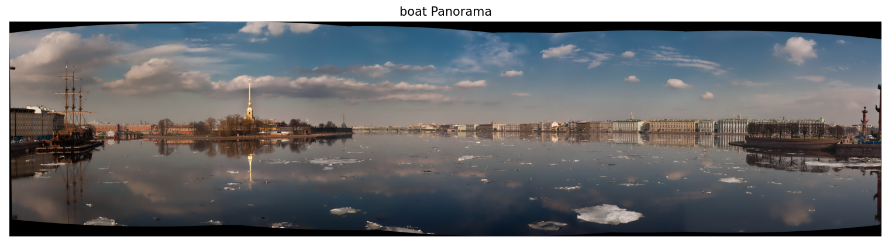

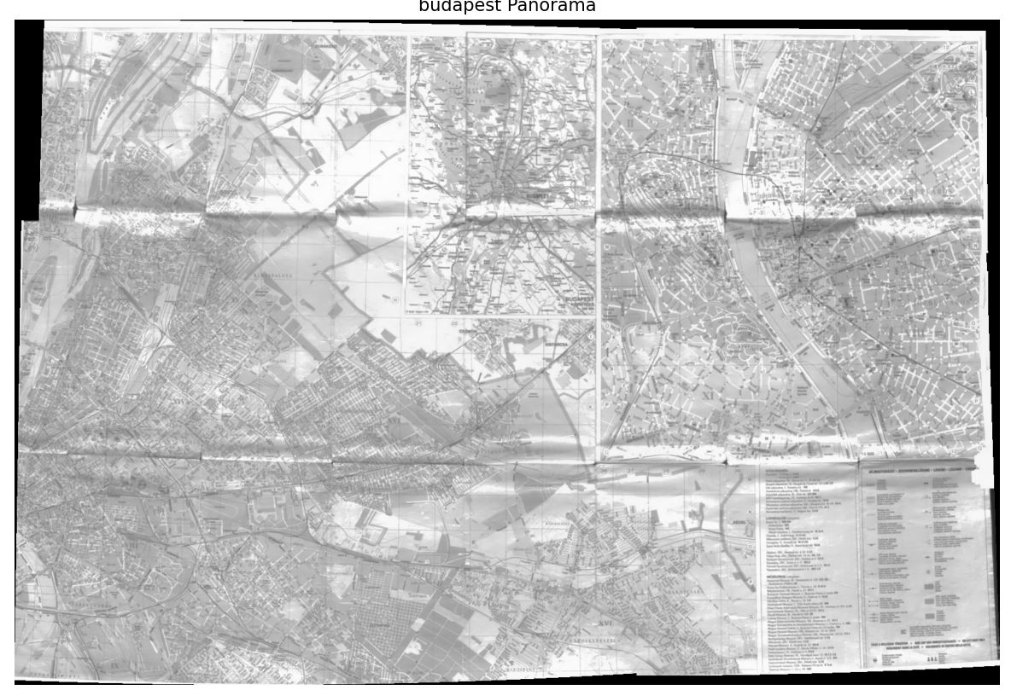

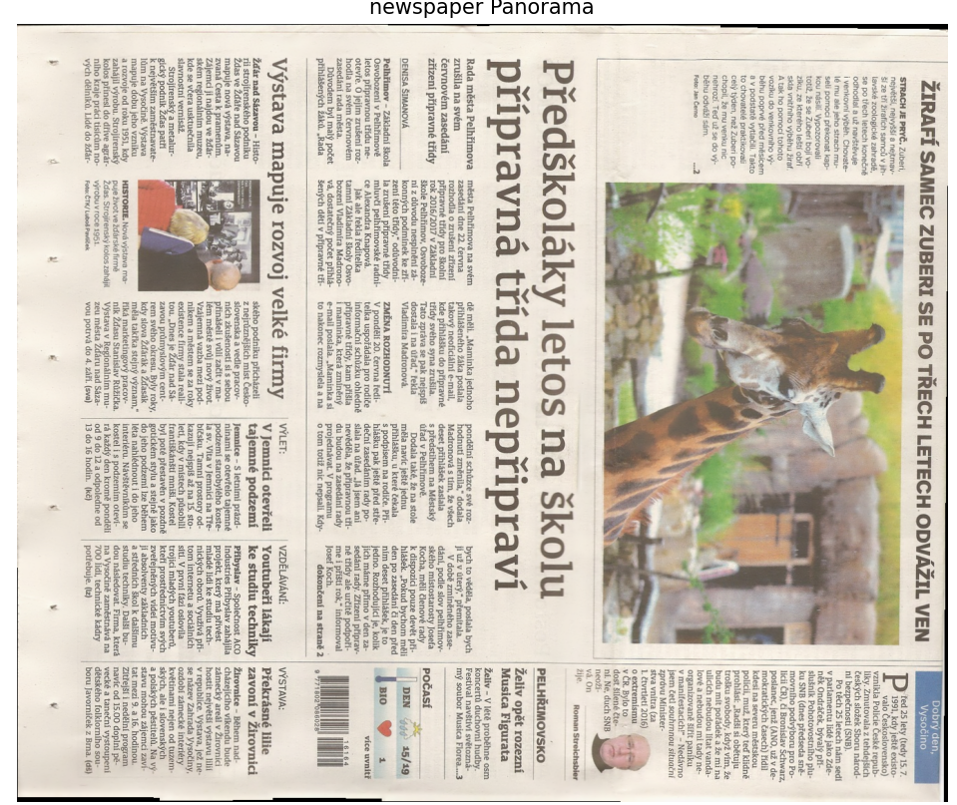

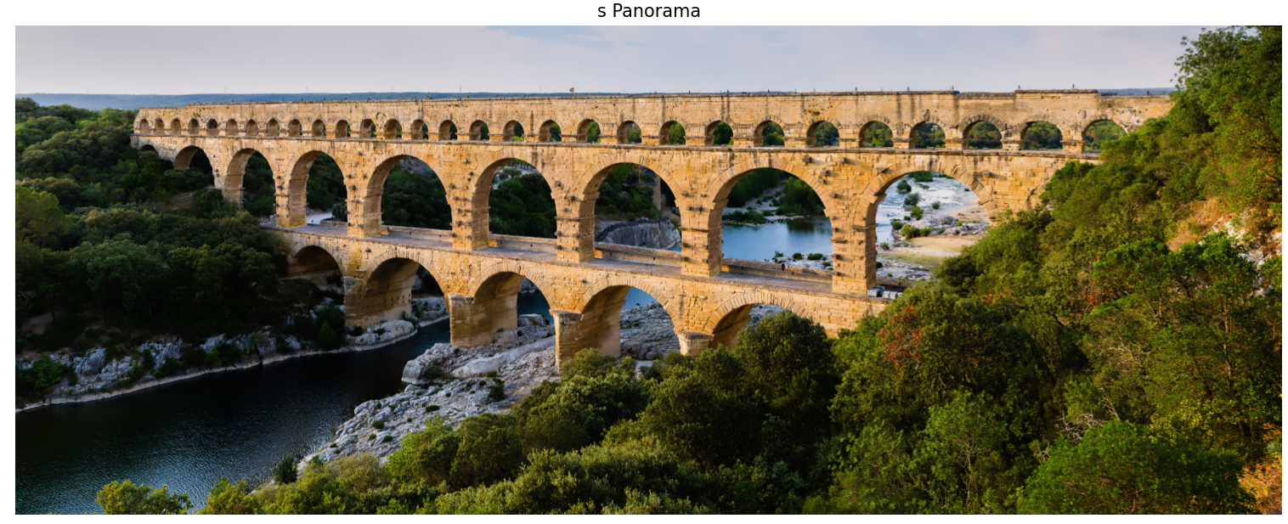

4. Optical Flow  
Stitching.zip에서 dog_a, dog_b 두 사진을 이용해서 Good feature to Track을 추출하고 Pyramid Lucas-Kanade 알고리즘을 적용해서 Optical Flow을 구하는 코드를 작성하시오.

import cv2  
from matplotlib import pyplot as plt  
  
def display_image_with_features(title, image, features):  
 for point in features:  
 x, y = point.ravel()  
 x, y = int(x), int(y) # 좌표를 정수형으로 변환  
 cv2.circle(image, (x, y), 5, (0, 255, 0), -1)  
 plt.figure(figsize=(10, 10))  
 plt.title(title)  
 plt.imshow(cv2.cvtColor(image, cv2.COLOR_BGR2RGB))  
 plt.axis('off')  
 plt.show()  
  
def display_optical_flow(image, features_a, features_b, status):  
 for i, (new, old) in enumerate(zip(features_b, features_a)):  
 if status[i]:  
 a, b = new.ravel()  
 c, d = old.ravel()  
 a, b = int(a), int(b)  
 c, d = int(c), int(d)  
 cv2.line(image, (a, b), (c, d), (0, 255, 0), 2)  
 cv2.circle(image, (a, b), 5, (0, 0, 255), -1)  
 plt.figure(figsize=(10, 10))  
 plt.title('Optical Flow')  
 plt.imshow(cv2.cvtColor(image, cv2.COLOR_BGR2RGB))  
 plt.axis('off')  
 plt.show()  
  
# 이미지 경로  
image_a_path = 'images/dog_a.jpg'  
image_b_path = 'images/dog_b.jpg'  
  
# 이미지 로드  
img_a = cv2.imread(image_a_path)  
img_b = cv2.imread(image_b_path)  
  
# 그레이스케일로 변환  
gray_a = cv2.cvtColor(img_a, cv2.COLOR_BGR2GRAY)  
gray_b = cv2.cvtColor(img_b, cv2.COLOR_BGR2GRAY)  
  
# Good Features to Track 추출  
features_a = cv2.goodFeaturesToTrack(gray_a, maxCorners=100, qualityLevel=0.01, minDistance=10)  
display_image_with_features('Good Features to Track - dog_a', img_a.copy(), features_a)  
  
# Pyramid Lucas-Kanade Optical Flow 계산  
features_b, status, _ = cv2.calcOpticalFlowPyrLK(gray_a, gray_b, features_a, None)  
  
# Optical Flow 결과 시각화  
display_optical_flow(img_b.copy(), features_a, features_b, status)

